
INDIRECTLY AIDS:
CONTRIBUTES TO:
AUTHORS:
Vince Nelmar P. Alobin
Qelvin Joseler Nagales
Marwin John Gonzales
Rick Francis T. Cruz

CO-AUTHORS:
Jose Eugenio L. Quesada

MERGE CONFLICT



AY 2025-2026
WAH4PCE: An AI-Driven Interoperability Bridge for iHOMIS

Table of Contents
List of Figures iv
List of Tables v
Introduction 1
Project Context 1
Statement of the Problem 1
Objectives 1
Significance of the Project 2
Scope and Limitations 2
Review of Related Literature / Systems 3
Current System 4
Technical Background 4
List of Processes 4
SWOT Analysis 5
Proposed Solution 5
Technical Background 5
Feasibility 5
Operational Feasibility 5
Economic Feasibility 5
Technical Feasibility 5
Schedule Feasibility 5
Requirements Analysis 5
Project Vision 5
Prototype (Mock Flow / Wireframe) 5
Project Lean Canvas 6
User Classes and Characteristics 6
Product Backlog 7
Product Roadmap 7
Release Plan 7
Use Case Diagram 7
Use Case Full Description 7
Conclusion 8
References 9
Appendices 10
Appendix A: Roles and Responsibilities 10
Appendix B: Minutes of the Meetings 11
Appendix C: Methodology 12
Appendix D: Project Sharepoint Link 13
Appendix E: Requirements Traceability Matrix 13
Appendix F: RACI Matrix 13

List of Figures
(
Add this to your paper if there you have inserted figures; otherwise, delete this section, including the header
To add a list of figures,
- Ensure that each figure has been properly captioned (Right click→Insert caption)
- Put the cursor below the List of Figures heading, then go to the References tab and click on Insert Tables of Figures located in the Captions group. The caption label should be set to Figure.
)

List of Tables
(
Add this to your paper if there you have inserted figures; otherwise, delete this section, including the header
To add a list of figures,
- Ensure that each figure has been properly captioned (Right click→Insert caption)
- Put the cursor below the List of Tables heading, then go to the References tab and click on Insert Tables of Figures located in the Captions group. The caption label should be set to Table.
)

Introduction
In many cases, healthcare suffers from the way patient information is stored and shared. As each hospital/clinic operates its own system for these purposes, it has been a challenge to transfer patient records between healthcare facilities. Even if connectivity is improved, as in the Wireless Access for Health (WAH) project, exchanging information between different systems remains a challenge. WAH is a non-government organization that aims to improve the healthcare system in the Philippines by giving its partner hospitals/clinics connectivity to build a more integrated system (Arnaout et al., 2014). However, because the patient records system is diverse (HIMS, etc.), the records cannot be shared because of the format used. This in turn results in slow care and information inconsistency.
The problem of exchanging data is a national problem that is targeted by the Universal Health Care (UHC) Act. The UHC Act requires the implementation of interoperable information systems and standardized health data collection (Republic Act No. 11223, 2019) This project builds upon the baseline interoperability system designed by (Cecilio et al., n.d.) by taking further through the full implementation of HL7 Fast Healthcare Interoperability Resources (FHIR) standard. The previous system serves as a baseline system, which provides connectivity. However, the previous system does not have a data standard that can be shared and understood by all participating systems.
To bridge this gap, this thesis focuses on FHIR mapping, which transforms the current local data formats into standardized models such as Patient, Observation, and Condition. This enables the effective sharing and interpretation of patient data with the same meaning between healthcare systems. The solution proposed therefore acts as an intermediary system that facilitates the flow of data between existing applications and ensures that the data shared is in a standardized format. As noted in Sinaci et al. (2023), the integration of FHIR mapping, compliance, and system integration aims to increase the effectiveness of patient data usage, consistency, and availability of patient records as mentioned throughout the WAH network.

Project Context
Healthcare in the Philippines currently faces a critical fragmentation challenge where patient information is trapped in isolated "data islands." While organizations like Wireless Access for Health (WAH) have improved physical connectivity, the digital systems used by partnered facilities, including HIMS, operate with incompatible data formats. This lack of a common language creates a significant hurdle when patients are referred between clinics and Department of Health (DOH) hospitals using systems like iHOMIS. When these records cannot be shared automatically, the result is a reliance on slow, manual processes that increase the risk of "garbage in, garbage out" data pollution and delay life-saving care.
Our project, WAH4PCE: An AI-Driven Automation Layer for PH Core FHIR Interoperability, is a direct technical response to this bottleneck. While previous batches (Cecilio et al., n.d.) established a baseline interoperability server and the core Philippine (PH) Core FHIR formats, the process of translating legacy records into those formats still relies heavily on human gatekeeping and manual verification. Our team bridges this gap by introducing an intelligent automation layer that serves as a Local Health Information Exchange (LHIE). This system is designed to act as the primary connection point between legacy WAH systems and the standardized DOH network, ensuring that data moves with "liquidity" and consistent clinical meaning.
The urgency of this project is heightened by the current national landscape. Although the Universal Health Care (UHC) Act mandates standardized data submission to the National Health Data Repository (NHDR), the development of this national infrastructure is currently on hold following changes in leadership. This creates a critical need for Local Government Units (LGUs) and organizations like WAH to lead the way by establishing their own FHIR-powered interoperability platforms. Our system achieves this by utilizing a modern tech stack. This stack consists of Go (Golang) for high-speed processing, MongoDB for native FHIR storage, and Next.js for administrative oversight.
Central to our solution is an AI-driven Mapping Engine that operates via a Model Context Protocol (MCP) server. This AI agent automatically parses legacy records and maps them to the PH Core FHIR standards established by the "Batch 1 WAH4PC" team, removing the need for manual re-encoding. To ensure the system is production-ready, we implement automated validation tools that verify the accuracy of every record before it reaches a DOH endpoint. While our team focuses exclusively on the automation and translation logic, the system is designed to seamlessly integrate with the security and encryption protocols provided by a separate project group to ensure full compliance with the Data Privacy Act of 2012.
Ultimately, our project goal is to deliver a functional, production-caliber proof-of-concept (POC) that demonstrates how WAH systems can seamlessly talk to DOH systems today. By automating the path to FHIR compliance, we provide WAH and its partners with the technical tools needed to fulfill the vision of the UHC law. This ensures that a patient’s record can follow them securely and instantly from a primary care clinic to a tertiary hospital.

Statement of the Problem
The primary problem is the lack of an automated, intelligent connection between WAH legacy systems and the standardized DOH EMRs (iHOMIS), preventing the realization of a functional Local Health Information Exchange.
Specifically, this study aims to answer the following problems:
- How can an AI-driven Integration Platform as a Service (iPaaS) be designed to replace manual data mapping and resolve format clashes between WAH legacy systems and DOH systems?
- How can this intelligent middleware facilitate the bidirectional, automated movement of records between WAH-partnered clinics and DOH-standardized hospitals?
- How can automated validation and filtering mechanisms be integrated into the exchange environment to prevent "garbage in, garbage out" data pollution?
- What technical safeguards can be implemented within the middleware to ensure explicit patient authorization during automated data movement, thereby avoiding "implied consent" violations under the Data Privacy Act?

Objectives
The main objective is to design and implement an AI-driven automation layer that connects WAH-partnered systems to DOH EMRs (iHOMIS) using the PH Core FHIR standard.

- To establish an automated interoperability bridge: Connect WAH facilities and DOH platforms by translating legacy records into the required formats.
- To build an intelligent iPaaS gateway: Serve as the automated routing hub that sits between WAH facilities and DOH platforms, managing the API handoffs.
- To develop a structural validation tool: Check all AI-translated records against the required data schemas (PH Core FHIR or DOH proprietary formats) to ensure data consistency and accuracy before transmission.
- To implement Consent-as-Code: Integrate a metadata-based "Consent Flag" check within the ADAPT engine to block any unauthorized data exchange.

Significance of the Project
This project offers significant benefits by enhancing healthcare efficiency and patient safety within the Wireless Access for Health (WAH) network. The specific groups that will benefit from this project are:

- For WAH and DOH: This project provides the first automated "proof of concept" (POC) that legacy local systems can communicate with national DOH systems, proving that interoperability is possible even while national infrastructure is on hold.
- For Healthcare Staff: By automating the translation, nurses and IT staff no longer must manually re-encode data or fix inconsistent formats when referring patients between clinics and hospitals.
- For Patients: Patients benefit from "data liquidity," where their medical history follows them instantly from a rural clinic (using WAH4H) to a government hospital (using iHOMIS).

Scope and Limitations

Scope:
- AI Automation Engine: The project focuses on building the AI logic that parses data and maps it to the PH Core FHIR resources provided by Batch 1 WAH4PC.
- Hybrid Data Training: The AI Engine will be trained using both PH Core FHIR standards and DOH-specific EMR formats to ensure high mapping accuracy between legacy systems and national standards.
- DOH System Integration: The system acts as the bridge specifically for iHOMIS, enabling WAH systems to "talk" to DOH-standardized EMRs.
- iPaaS Middleware Integration: The ADAPT system operates strictly as an Integration Platform as a Service (iPaaS). Rather than serving as the central database itself, it functions as the intelligent routing middleware that sits between the DOH endpoints (iHOMIS) and the WAH network, facilitating the secure, automated movement and translation of data.
- Automated Validation: Implementation of AI-driven "cleaners" to standardize and validate data during the exchange process.
- The system includes automated "Consent-as-Code" checks and structural FHIR validation for WAH4H and DOH IHomis data formats.

Limitations:
- Static Data Standards: The project will not create new FHIR formats; it relies strictly on the PH Core standards that were already established and complying with the PhilHealth guidelines.
- External Dependencies: System testing is contingent upon the availability of mock endpoints for the WAHpatients and WAH hospital modules being developed by other teams.
- Testing with Dummy Data: Due to privacy laws, We do not have direct access to live DOH or WAH production databases, our team will develop functional dummy system endpoints simulating an iHOMIS environment and a WAH hospital environment. These dummy systems will be used strictly to validate the iPaaS data exchange and demonstrate the bidirectional transformation capabilities.
- The validation tool checks for structural accuracy and missing fields but does not verify the clinical truth of the medical data provided by the source system.

Review of Related Literature / Systems
The landscape of healthcare is undergoing significant metamorphosis driven by digital transformation. This evolution, while promising enhanced efficiency and patient care, hinges on various factors, including technology acceptance and the effective implementation of digital tools.
One of the pioneering studies that shed light on this shift in the industry is the work of Nassr, Al-Shamayleh, and Al-Shboul (2023). The authors investigate various aspects of how healthcare professionals and patients are adopting new technologies. Specifically, the authors investigate the factors that make healthcare professionals more or less likely to adopt these technologies.
Another study that investigates this same topic but with a focus on the local area is by Llanes et al. (2024), who investigate the current state of the Electronic Health Record (EHR) system in the Philippines. The authors reveal valuable insights into the current state of the EHR system in the Philippines. Furthermore, because there are some disconnected EHR systems within the Philippines, there is a recognized need for a system that can provide a standard system for the data to be exchanged between these disconnected systems.
The digital tools can be further seen in the work of Singh et al. (2024), who discuss the potential of artificial intelligence to improve health outcomes through earlier and more accurate diagnoses.
The benefits and the challenges of Electronic Health Records (EHRs) are discussed by Simbo.ai (2023). The authors explain how these systems can lead to improved health information management and health care professionals’ workflows, but also present issues with interoperability between different health systems. Most health systems utilize slightly different structures of their internal data from others in the industry, preventing interoperability between these health records databases.
To overcome these interoperability challenges, the healthcare industry has used the HL7 Fast Healthcare Interoperability Resources (FHIR) standard (Adegoke et al., 2025). HL7 FHIR allows healthcare data to be represented in a standard format using modular resources. Using this standard, systems can exchange data with semantic interoperability. FHIR requires a full mapping from the existing databases to the FHIR standard to enable interoperability between these two systems. Several research studies have explored how to create interoperable and reusable health data using the FHIR standard (Sinaci et al., 2023). Additionally, there are several studies exploring the semantic issues of FHIR and implementing the FHIR standard within EHR systems (Amar et al., 2024). These solutions will eliminate data silos and enable better communication between systems.
Finally, the broader implications for healthcare quality and safety are discussed by Alshurideh et al. (2024). Their work highlights how digital transformation improves service delivery, particularly when systems are integrated and capable of sharing accurate data. The effectiveness of these improvements depends on the ability of systems to communicate reliably, further reinforcing the importance of standardized interoperability frameworks such as FHIR.
Through reviewing the literature, it is evident that there is both a global and local movement toward the digitization of healthcare. The literature discusses, for instance, the acceptance of technology in healthcare (Nassr et al., 2023), the challenges of implementing Electronic Health Records in healthcare facilities (Charalambous, 2024), the role that advanced technologies play in improving healthcare outcomes (Singh et al., 2024), and the impact of digitization on healthcare (Alshurideh et al., 2024). Furthermore, systems like CHITS, and iHOMIS have allowed for the digitization of certain processes within the Philippines (Inquirer Business, 2025; Ongkeko et al., 2016; Philippine Council for Health Research and Development, n.d.; Scribd, n.d., 2021; UIJRT, n.d.) but also demonstrate the limitations of such systems implemented alone. Thus, the literature indicates a need for a system that provides interoperability for the country’s healthcare systems. Such interoperability could be achieved through the implementation of a system that maps each healthcare system to the FHIR standard, which would guarantee compliance with the UHC law (Philippine Statistics Authority, 2025; Scribd, 2021) and lead to the integration of the entire Philippine healthcare system.
According to research by Nan and Xu (2023), the biggest obstacle to the digital transformation in healthcare is the existence of so-called data islands. Even as medical records are increasingly going digital, the data are still confined to heterogeneous Information Technology (IT) systems that lack a common language. This fragmentation does not allow providing coordinated care and narrows the utility of clinical decision-support tools (Nan & Xu, 2023).
The researchers refer to Fast Healthcare Interoperability Resources (FHIR) as the most promising solution to this issue. Unlike the previous messaging standards, which were complex and rigid, FHIR leverages the current web technologies i.e. RESTful API and modular Resources (Nan and Xu, 2023). They consist of standardized building blocks, including Patient, Medication and Procedure, which are shared between different systems in order to share certain bits of information efficiently. Flexibility of FHIR is highlighted in the literature, with the mention of the fact that it can be applied to various platforms, such as mobile health apps and cloud systems (Nan and Xu, 2023).
Nan and Xu (2023) formulate three areas of critical importance on the basis of a systematic review of 85 scholarly articles:
- Data Standardization and Mapping: A sizeable portion of the literature is focused on the transformation process, i.e. how to convert the current legacy data, e.g. CDA or HL7 v2, to FHIR-conformant data. This is critical in making sure that information from various time periods and systems can be successfully merged (Nan & Xu, 2023).
- Data Management and Storage: The review explains the architecture of FHIR servers and emphasizes the need to have robust architecture that can address large-scale "Big Data" and maintain high rates of security and privacy controls to protect confidential patient information (Nan & Xu, 2023).
- Clinical Services Data Interoperation: This paper goes beyond mere technical exchange to emphasize "semantic interoperability." This has been determined as the ability of systems to not only communicate its content but also the meaning and react to it, which will allow the provision of higher-level services like real-time patient tracking and research across institutions (Nan & Xu, 2023).
The proposal of a General FHIR Practice Guideline (FHIR PG) is one of the important contributions of this research. In their argument, Nan and Xu (2023) argue that standardization is not a technical undertaking but a team effort. Their model defines the roles of different groups of stakeholders to be successful: to prevent the non-compatibility of different versions of FHIR, the standardizers need to create particular Implementing Guides; the system provider needs to create the infrastructure and servers to store such data; and the service provider (app developers) needs to create user-facing tools to transform this data into improved clinical outcomes (Nan & Xu, 2023).
The transition from manual paper-based reporting to electronic health records (EHRs) in the Philippines, led by initiatives like Wireless Access for Health (WAH), necessitates a theoretical framework for seamless data exchange. According to Vorisek et al. (2022), the FHIR standard serves as this framework by utilizing modern web technologies such as RESTful APIs and JSON to ensure that health data adheres to the FAIR Principles (Findable, Accessible, Interoperable, and Reusable). In the context of the Philippines' Universal Healthcare Act, the literature emphasizes that "data liquidity"—the ability of data to move securely and meaningfully between systems—is the next frontier for digital health. Vorisek et al. argue that FHIR’s "resource" building blocks allow for the modular development of health systems, which aligns with WAH's open-source philosophy. However, the literature also warns of significant bottlenecks, including the "versioning" of FHIR resources and the legal complexities of cross-institutional data sharing, which remain primary challenges for the Philippines as it seeks to harmonize fragmented local health information into a unified national repository.
The landscape of digital health in the Philippines is governed by DOH-PHIC Joint Administrative Order (JAO) No. 2021-0002, which institutionalizes the Mandatory Adoption and Use of National Health Data Standards for Interoperability. This policy serves as the regulatory backbone for the Universal Health Care (UHC) Act, recognizing that "seamless and interoperable health services" are essential for evidence-based sectoral planning. According to the JAO, the current inconsistent adoption of data standards prevents healthcare providers from sharing medical records for continuing care, a critical challenge for decentralized systems like Wireless Access for Health (WAH). By mandating a "common data language" through the National Health Data Dictionary (NHDD), the order ensures that health data—whether from a rural health unit or a tertiary hospital—can be analyzed for national program planning and decision-making.
Furthermore, the JAO defines interoperability through a structured set of National Health Data Standards, which include specific data elements, official definitions, and standardized data types (e.g., text, numeric, and date formats). This policy framework supports the "FAIR" principles (Findable, Accessible, Interoperable, and Reusable) discussed by Vorisek et al. (2022) by providing the legal requirement for systems to utilize authoritative terminology services. For local health initiatives, compliance with these standards is now a prerequisite for licensing and accreditation, effectively making technical interoperability a mandatory operational standard rather than an optional technical feature (DOH & PhilHealth, 2021).

The global trajectory of healthcare informatics is increasingly defined by the transition from localized data digitization to the pursuit of semantic interoperability. As highlighted by Balch et al. (2023), while the post-HITECH era has catalyzed the widespread adoption of Electronic Health Records (EHRs), the clinical utility of this data remains hindered by fragmented architectures and variable implementation methods. The study posits that the lack of standardized data formats across institutions creates significant barriers to real-time clinical analysis and multi-institutional research. To mitigate these "data silos," the Fast Healthcare Interoperability Resources (FHIR) standard has emerged as the premier technical framework for achieving a unified data language. By utilizing a "resource-based" approach, FHIR provides the necessary modularity to transform disparate clinical narratives into structured, machine-readable formats, ensuring that health data is not merely digitized but truly interoperable (Balch et al., 2023).
Furthermore, the research underscores that the adoption of FHIR is a foundational requirement for the advancement of Machine Learning-enabled Clinical Information Systems (ML-CISs). By evaluating 39 distinct systems, the study categorizes these technological advancements into three functional domains: clinical decision support systems, data management and analytic platforms, and auxiliary modules or application programming interfaces (APIs). This taxonomy demonstrates that the "FAIR" principles (Findable, Accessible, Interoperable, and Reusable) are realized through the automation of data mapping and the reduction of manual pre-processing (Balch et al., 2023). Despite these advancements, many intelligent systems continue to face critical challenges regarding external validation and seamless integration into existing clinical workflows. Consequently, the findings suggest that the future of digital health lies in the development of secure, scalable, and interinstitutional data exchange protocols that can accommodate diverse electronic health record platforms (Balch et al., 2023).

List of Processes

(Note: The provided table below is just an example of informing your readers of the current processes being performed by your client. You may have processes as subsections, and in each subsection, you either list the steps or draw a flowchart of actions – make sure you identify who the doer of the actions).
Table 1 List of Processes in the Current System
Process ID | Process Name | Process Details
P001 | Patient Record Submission | 1. Health Facility Staff enter clinical data into the local electronic medical record (EMR).  2. The system bundles the data into a local JSON format.  3. The record is queued for validation against the WAH Format inspired by the PH Core profile.
P002 | FHIR Data Validation | 1. The AI automation layer intercepts the incoming record.  2. The system checks the data against HL7 FHIR standards and Philippine legal waiver requirements.  3. If errors are found (e.g., missing mandatory fields), a notification is sent back to the facility for correction.
P003 | Data Mapping & Transformation | 1. Validated local data is mapped to specific PH Core profiles (e.g., Patient, Encounter, Observation).  2. The system transforms local terminology into standardized codes recognized by the DOH and.
P004 | Registry Synchronization | 1. The system establishes a secure connection with national registries (e.g., DOH).  2. Validated and standardized records are pushed to the central registry.  3. The system receives and logs a "Success" or "Acknowledgement" receipt from the government server.

( Please include a table caption. At the end of the table, you may include process details not covered in the table. You may write the processes as flowcharts or pseudocodes. Note that captions are required for both for referencing. Also, remember to put a sentence or two to describe any table in the document. Like, “Table 1 contains a list of all the process that are currently being applied by the business”.)
Product Inquiry
- Customer initializes conversation in Facebook Messenger.
- Seller acknowledges customer.
- Customer asks about item.
- Seller responds with item information.
Product Purchase
- Customer writes an “intent to buy” message via Facebook Messenger.
- Seller responds with item price and delivery details
- Customer sends payment proof.
- Seller confirms order.

SWOT Analysis

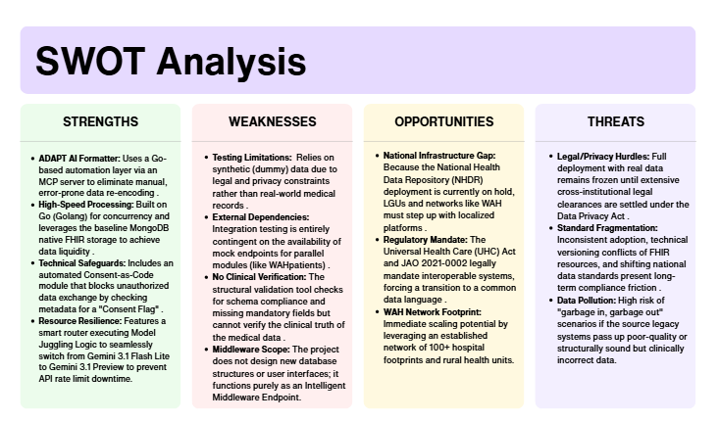
Figure 1.0 SWOT ANALYSIS
Outlines the internal architectural strengths and testing boundaries of the interoperability middleware against external regulatory opportunities and localized data risks in the Philippine healthcare ecosystem.

Proposed Solution

Technical Background
To resolve manual bottlenecks within the WAH network, the proposed solution introduces a specialized AI automation function named ADAPT (Automated Data Processing and Transformation). ADAPT functions as an Integration Platform as a Service (iPaaS) and an Intelligent Middleware Endpoint. It is important to note that our scope is strictly building this iPaaS middleware. Establishing the actual connections, configuring the outbound webhooks, and providing the official iHOMIS API keys for deployment will be the sole responsibility of the Batch 1 team and WAH administrators.
1. Software Technologies
- AI Orchestration Engine: To power ADAPT during the testing and prototyping phase, the system utilizes the Gemini API via a smart router function, primarily using Gemini 3.1 Flash Lite and Preview for high-volume translations. However, for actual clinical deployment, WAH will provide their own official, production-grade AI model to plug into the ADAPT architecture to ensure strict, localized data privacy compliance.
- AI Tooling (Model Context Protocol): The Gemini models are controlled through an MCP server. This allows the AI to use specific tools, such as the SourceDataParser, to understand WAH4H data and the FHIRMappingTool to generate valid PH Core JSON files.
- Consent-as-Code Module: This automated filter scans record metadata for a "Consent Flag" before any AI processing begins. If the flag is missing, the mapping function is blocked to ensure compliance with the Data Privacy Act.
- Structural Validation Module: All AI-translated resources are automatically checked against the PH Core FHIR schema. Records missing critical data, such as PhilHealth IDs or birthdates, are quarantined for manual review.
2. Hardware Technologies
- Go (Golang) Middleware: The "model juggling" logic is written in Go to take advantage of its high-speed concurrency. This allows the system to switch models in milliseconds without dropping the data payload.
- API Load Management: The system is hosted on the existing Batch 1 Proxmox cloud environment. It uses secure API keys to connect to Google’s AI endpoints, ensuring that even during model switching, the data remains encrypted and protected.
3. Peopleware
- AI Integration Engineers: Personnel responsible for prompt engineering and API management using Gemini 3.1 Preview to ensure mapping accuracy.
- Data Quality Administrators: IT staff who monitor the automated quarantine logs and manually review records that fail the structural validation check.
- Systems Integration Leads: Staff focused on maintaining the connection between the AI endpoint and the existing Batch 1 MongoDB repository and FHIR server.

4. Network Technologies
- Secure Middleware Endpoints: The system operates as a RESTful API middleware. It receives raw data via HTTPS and sends validated FHIR resources to the central server using Transport Layer Security (TLS).
- Encrypted Tunneling: While our group does not build the security layer, the automation endpoint is designed to operate within the secure VPN tunnels provided by the parallel security team.

Feasibility

Operational Feasibility
WAH4PCE project rests on its ability to seamlessly integrate into the daily workflows of rural health units and district hospitals without disrupting patient care. Currently, healthcare workers frequently struggle with the administrative burden of double data entry, manually inputting patient records into the local Wireless Access for Health (WAH) platform and then duplicating that data within the Department of Health’s (DOH) Integrated Hospital Operations and Management Information System (iHOMIS) for referrals or admissions.
By establishing an automated interoperability bridge, the system operates invisibly in the background, minimizing data entry errors, eliminating redundant administrative tasks, and speeding up client processing times. Because medical staff are already deeply familiar with their respective platforms, user resistance will be minimal, and training will focus strictly on verifying data-syncing statuses and processing digital data privacy consent forms.
Furthermore, this initiative directly aligns with the organizational mandates of Universal Health Care (UHC) in the Philippines, ensuring strong backing from local government health boards, hospital administrators, and the DOH, provided strict protocols are established to maintain compliance with the Data Privacy Act of 2012 (RA 10173).

Economic Feasibility
From an economic perspective, the financial viability of the project is highly secure, as the WAH Non-Government Organization (NGO) has officially committed to absorbing all core capital and operational expenses. A significant portion of the upfront infrastructure cost is already eliminated because the WAH NGO is providing a dedicated local server to host the integration system. Financial planning and the integrated AI models will therefore focus heavily on predicting, tracking, and optimizing operational expenses, such as long-term data bandwidth costs, local server power efficiency, hardware maintenance, and emergency IT support.
By eliminating expensive proprietary software licensing fees through the use of open-source and custom-built tools, the financial risks are remarkably low. In return, the financial benefits to the public health system remain substantial; automating the data pipeline saves hundreds of collective clerical hours across municipal health centers, translating directly into optimized personnel allocation, faster referral windows, and a significant reduction in rejected PhilHealth claims.

Technical Feasibility
The technical feasibility of connecting WAH to iHOMIS is exceptionally strong, utilizing a modern, scalable, and high-performance technology stack deployed directly onto the local server provided by the WAH NGO. The user-facing configuration and monitoring dashboards will be built using Next.js for a responsive, modern front-end experience, while the core interoperability bridge, API routing, and data-mapping services will be handled by Go (Golang) to ensure ultra-low latency and highly efficient concurrent processing. For the data layer, MongoDB will be utilized as a flexible, document-based database capable of efficiently handling disparate, semi-structured health records and transaction logs before they are transformed. The local server will host this full-stack environment alongside the integration middleware that maps local data to the DOH iHOMIS backend.
To ensure strict adherence to national health data standards, the Go backend will explicitly reference the HL7 FHIR R4 framework and the Philippine FHIR Core (PH Core) profiles to programmatically transform and translate incoming data payloads into standardized, compliant JSON health resources. To address the infrastructure challenges of remote Philippine municipalities, the Go backend will run a robust "Store-and-Forward" mechanism, allowing data to be queued securely in MongoDB when internet connectivity drops and automatically synchronizing it with the DOH endpoints once the wireless connection is restored. Security is tightly integrated, utilizing TLS 1.3 encryption for data in transit, cryptographic protection for data at rest on the local server, and strict access controls via OAuth 2.0.

Schedule Feasibility
The schedule feasibility is highly viable, structured as a one-year project that strictly adheres to the systematic stages outlined in the academic course flowchart. The project lifecycle is divided into clear milestones across the year to ensure a logical transition from ideation to deployment.
- Research & Development (Term 1): The initial phase is dedicated entirely to core R&D, where the research team will conceptualize the interoperability bridge, analyze the data endpoints of both systems, and formulate a comprehensive structural blueprint for the integration architecture.
- Design & Prototyping (Term 2): Building on this conceptual foundation, the team will design detailed system, architectural, and data-flow diagrams to map WAH structures to the PH Core and HL7 FHIR R4 standards. This phase culminates in the construction of a working prototype to validate the data transformation logic and local server communication.
- Development & Technical Documentation (Term 3): The final phase focuses heavily on full-scale development, implementing the production-ready Next.js frontend, Go backend, and MongoDB database on the WAH-provided local server. Parallel to code development, rigorous system documentation will be compiled, covering API endpoints, data transformation pipelines, security audits, and deployment guides to ensure system sustainability.

Requirements Analysis

Project Vision

Prototype (Mock Flow / Wireframe)
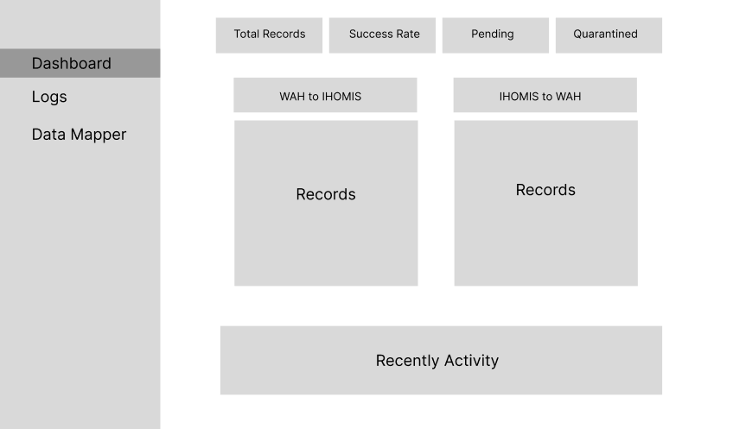
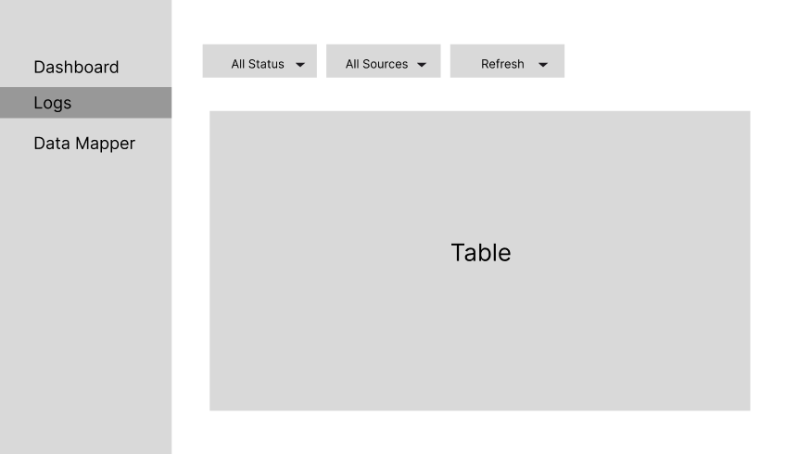
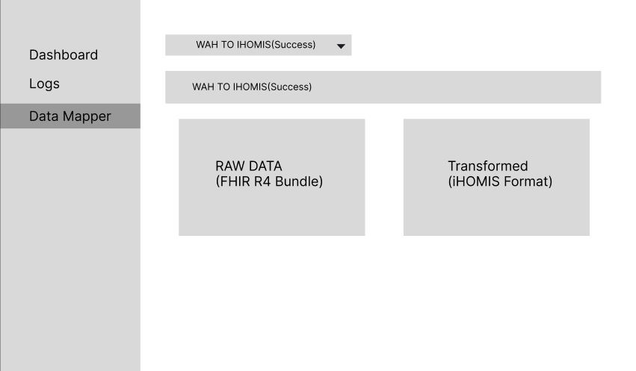

Project Lean Canvas
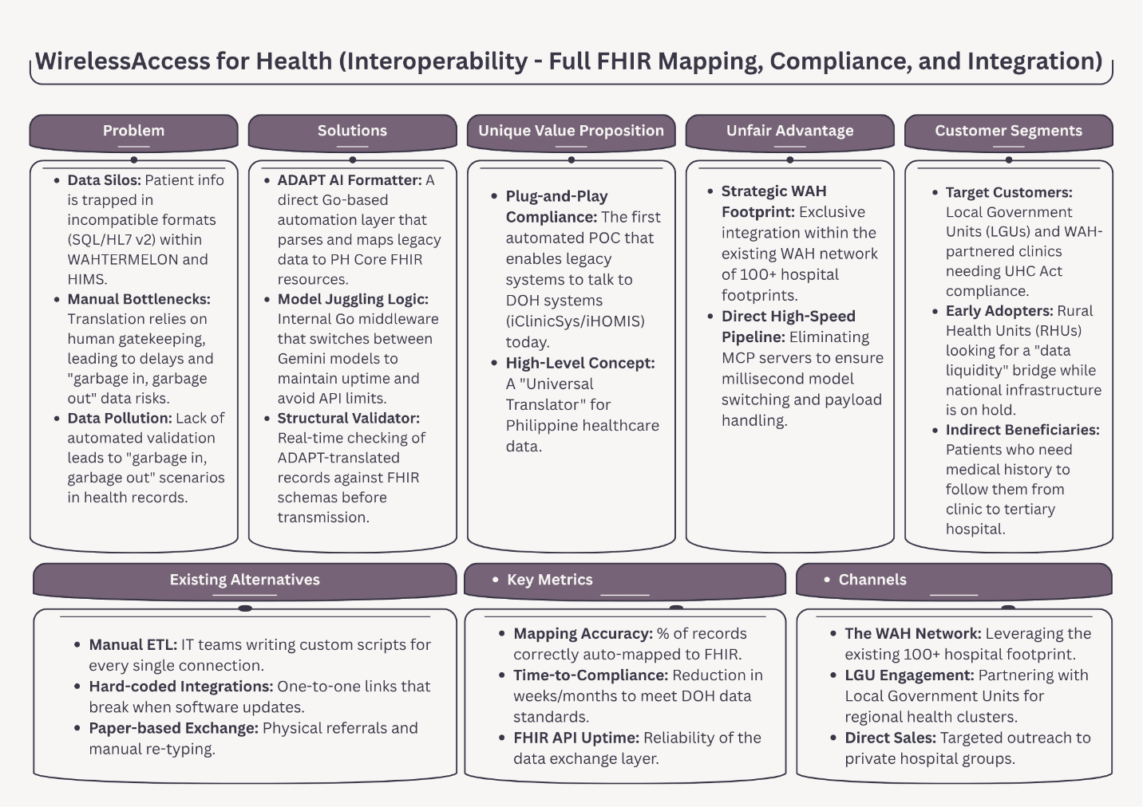
Figure 1.1 Lean Canvas
Maps the project’s business strategy, highlighting how the middleware solves legacy data silo problems by utilizing the existing WAH network to deliver a plug-and-play FHIR compliance solution.

User Classes and Characteristics
(
Insert a table here with two columns: Roles and Description
Roles | Description
Student Org Representative | A student organization representative is a type of user. When this user makes a request, the request must be approved by the org adviser, etc..
Org adviser | This user approves or disapproves the request made by the representatives of the org he/she handles.

)

Product Backlog
(Create a table here like the one below. Do not create a table in Excel and insert the table here as image.)
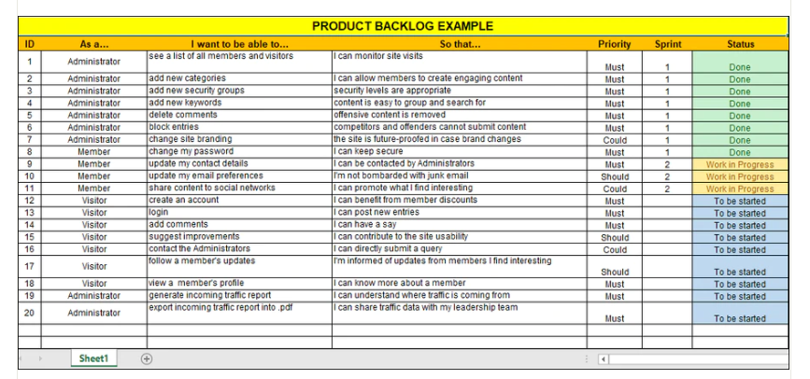

Product Roadmap
(Create your product roadmap. Template can be found in the CoursePack)

Release Plan
(
Include here your updated release plan and discuss whether you are on/ahead/behind schedule. Explain also how much of the product backlog has been finished (it is up to you how you will present it, without being repetitive. You can say something like, “The complete product backlog is in Table ___”. Note: template can be found in the CoursePack.
)

Use Case Diagram
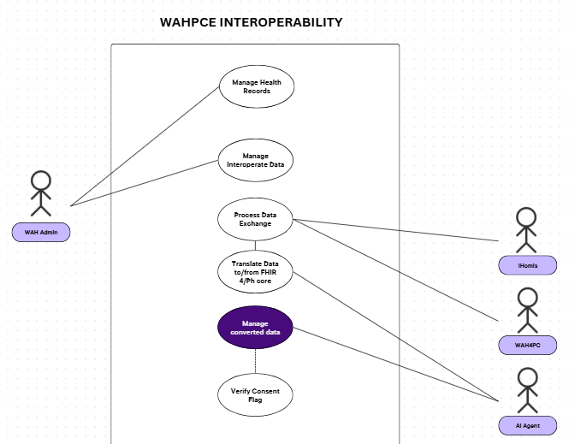
Figure 1.2 Use Case Diagram
Illustrates the functional boundaries and interactive relationships between the WAH Admin, external healthcare applications (iHomis, WAH4PC), and the AI Agent during FHIR data translation and consent verification.

Use Case Full Description

Conclusion
(
Write what you have accomplished so far (which of your objectives have been achieved and what needs to be done to achieve the others, if there are still any left). Summarize what you have done: specify the objectives and briefly describe how it was achieved. At the end of this chapter, write what will be done for the next iteration (for the next PBL subject)
)

References

Adegoke, K., Adegoke, A., Dawodu, D., Adekoya, A., Bayowa, A., Kayode, T., & Singh, M. (2025). Interoperability as a Catalyst for Digital Health and Therapeutics: A Scoping Review of Emerging Technologies and Standards (2015–2025). International Journal of Environmental Research and Public Health, 22(10), 1535. https://doi.org/10.3390/ijerph22101535
Alshurideh, M., Al Kurdi, B., AlHamad, A. Q., Salloum, S. A., Al-Emran, M., & AbuGhoush, Q. (2024). Assessing the impact of digital transformation on healthcare services: A focus on quality and safety. BMJ Open Quality, 13(2), e002621. https://doi.org/10.1136/bmjoq-2023-002621
Amar, F., April, A., & Abran, A. (2024). Electronic health record and semantic issues using Fast Healthcare Interoperability Resources: Systematic mapping review. Journal of Medical Internet Research, 26, e45209. https://doi.org/10.2196/45209
Arnaout, S., Jeanty, N., Keane, H., & Mkemwa, G. (2014). The Effect of the Wireless Access for Health Electronic Health Record System on Rural Health Units in the Philippines. https://wah.ph/wp-content/uploads/2023/07/The-Effect-of-the-Wireless-Access-for-Health-Electronic-Health-Record-System-on-Rural-Health-Units-in-the-Philippines.pdf
Balch, J. A., Ruppert, M. M., Loftus, T. J., Guan, Z., Ren, Y., Upchurch, G. R., Ozrazgat-Baslanti, T., Rashidi, P., & Bihorac, A. (2023). Machine Learning–Enabled Clinical Information systems using fast healthcare interoperability Resources Data Standards: Scoping review. JMIR Medical Informatics, 11, e48297. https://doi.org/10.2196/48297
Bossenko, I., Randmaa, R., Piho, G., & Ross, P. (2024). Interoperability of health data using FHIR Mapping Language: transforming HL7 CDA to FHIR with reusable visual components. Frontiers in Digital Health, 6, 1480600. https://doi.org/10.3389/fdgth.2024.1480600
Cecilio, M. C. T., Garcia, C. A., & Tengco, J. R. B. (n.d.). Wireless access for health for interoperability [Unpublished project documentation]. School of Computing and Information Technologies, Asia Pacific College.
Charalambous, A. (2024). Digital transformation in healthcare: Have we gone off the rails? Asia-Pacific Journal of Oncology Nursing, 11(5), 100481. https://apjon.org/article/S2347-5625(24)00101-X/fulltext
Department of Health & Philippine Health Insurance Corporation. (2021, April 21). Mandatory adoption and use of national health data standards for interoperability (Joint Administrative Order No. 2021-0002). https://law.upd.edu.ph/wp-content/uploads/2021/06/DOH-PHIC-JAO-No-2021-002.pdf
Inquirer Business. (2025, June 9). Enabling universal health care in the Philippines. https://business.inquirer.net/529621/enabling-universal-health-care-in-the-philippines
Nan, J., & Xu, L. (2023). Designing Interoperable health care services based on Fast healthcare Interoperability Resources: Literature review. JMIR Medical Informatics, 11, e44842. https://doi.org/10.2196/44842
Nassr, A. A., Al-Shamayleh, H. R., & Al-Shboul, M. F. (2023). Digital transformation in healthcare: Technology acceptance and its applications. WSEAS Transactions on Systems and Control, 18, 86–95. https://doi.org/10.37394/23203.2023.18.10
Ongkeko, A. M., Jr., Fernandez, R. G., Sylim, P. G., Amoranto, A. J. P., Ronquillo-Sy, M.-I., Santos, A. D. F., & Tolentino, J. G. (2016). Community health information and tracking system (CHITS): Lessons from eight years implementation of a pioneer electronic medical record system in the Philippines. Acta Medica Philippina, 50(4), 265–273. https://www.researchgate.net/publication/313893323
Philippine Council for Health Research and Development. (n.d.). Community health information tracking system (CHITS). https://www.pchrd.dost.gov.ph/heartnovation/community-health-information-tracking-system-chits/
Philippine Information Agency. (2024, February 28). DOH launches integrated info system for healthcare improvement. https://pia.gov.ph/doh-launches-integrated-info-system-for-healthcare-improvement/
Philippine Statistics Authority. (2025, April 30). PSA clears the “Evaluation of the Universal Health Care (UHC) health information systems (HIS)” survey, encourages participation for data-driven evaluation by HIS interoperability, functionality, and impact on UHC implementation. https://psa.gov.ph/content/psa-clears-evaluation-universal-health-care-uhc-health-information-systems-his-survey
Republic Act no. 11223, Official Gazette of the Republic of the Philippines (2019). https://www.officialgazette.gov.ph/2019/02/20/republic-act-no-11223/
Scribd. (2021, November 9). Integrated hospital operations and management information system (iHOMIS). https://www.scribd.com/presentation/543228631/IHOMIS-Presentation
Simbo.ai. (2023, November 17). Understanding electronic health records: Benefits and implementation challenges in modern healthcare delivery systems. https://www.simbo.ai/blog/understanding-electronic-health-records-benefits-and-implementation-challenges-in-modern-healthcare-delivery-systems-1611764/
Sinaci, A. A., Gencturk, M., Teoman, H. A., Laleci Erturkmen, G. B., AlvarezRomero, C., MartinezGarcia, A., PobladorPlou, B., CarmonaPírez, J., Löbe, M., & ParraCalderon, C. L. (2023). A data transformation methodology to create findable, accessible, interoperable, and reusable health data: Software design, development, and evaluation study. Journal of Medical Internet Research, 25, e42822. https://doi.org/10.2196/42822
Singh, R., Mathur, N., Singh, A., Sangwan, S., & Pitalia, A. (2024). Artificial intelligence-guided clinical decision support system for early prediction of neonatal sepsis: A prospective diagnostic validation study. Asia Pacific Journal of Oncology Nursing, 11(4), 100401. https://doi.org/10.1016/j.apjon.2024.100401
ThinkWell Global. (n.d.). The Philippine UHC law series: Brief 1. https://thinkwell.global/wp-content/uploads/2020/05/PH-UHC-Law-Series_Brief-1.pdf
University of the Philippines Manila Standards and Interoperability Lab. (n.d.). PH Core implementation guide. https://build.fhir.org/ig/UP-Manila-SILab/ph-core/
Vorisek, C. N., Lehne, M., Klopfenstein, S. a. I., Mayer, P. J., Bartschke, A., Haese, T., & Thun, S. (2022). FaST Healthcare Interoperability Resources (FHIR) for Interoperability in Health Research: Systematic review. JMIR Medical Informatics, 10(7), e35724. https://doi.org/10.2196/35724

Appendices
(Add more appendices when necessary)

Appendix A: Roles and Responsibilities

Appendix B: Minutes of the Meetings
(
Include here the minutes of the meetings with your adviser/consultant/client.
)

Appendix C: Methodology

Appendix D: Project Sharepoint Link
Merge Conflict - SharePoint Site Link

Appendix E: Requirements Traceability Matrix

Appendix F: RACI Matrix

